|  |  |  |  |  |  |  |  |  |
| --- | --- | --- | --- | --- | --- | --- | --- | --- |
| Subject code | : | CE143 | Semester | : | 1 | Academic Year | : | 2023-2024 |
| Subject name | : | Computer Concepts and Programming | | | | | | |

# Instructions for Coding standards:

* First line in any program must be “/* This program is prepared by 23TCE0XX_Name */”.derstand the problem and draw the flowchart for planned solution and write algorithm.
* **Indentation:** Ensure proper indentation in code.
* **Naming Conventions:** Ensure appropriate naming conventions for variables (CamelCase is mandatory).
* **Comments:** Ensure single line or multiline comments in code.
* Habituate yourself for revising code in order to solve errors.

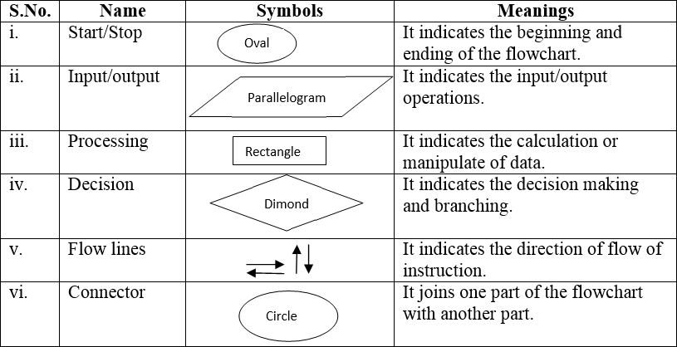**Essential symbols for flowchart:** [Students may use additional structures in certain cases to increase knowledge transfer]

# Rubrics:

|  |  |  |  |
| --- | --- | --- | --- |
| **Criteria** | **Excellent 5** | **Good 3** | **Poor 1** |
| Flowchart and Algorithm | Ensured correct use of Flowchart symbols, also  flow of solution and algorithm are matching | Correct use of flowchart symbols but  mismatch in flowchart and algorithm | Either Flowchart or Algorithm is missing |
| Coding Standards (Naming Conventions,  Indentation, Comments) | All 3 ensured | Any two ensured | Any one ensured |
| Output as per Expectation (Attach output screenshot and filled the table) | Attached screenshot of output and filled the table | Attached screenshot of output but not filled the table | Neither Screenshot attached nor filled the table |

|  |  |
| --- | --- |
|  | **Practical** |
| **Program: 4** | 1. Write something about your characteristics not more than 50 words using gets function and print out the same using puts function. Expected Outcome: Draw flowchart, write algorithm and write program for given scenario. Also attach the screenshot of output. Questions: What is the significance of using gets and puts? Are they acting as replacement of any function? How? 2. Write a program to convert the decimal number into octal and hexadecimal format. Print hexadecimal and octal values for given inputs in expected outcomes. Hint: Use %o and %u. |

|  |  |
| --- | --- |
| **Flowchart** |  |
| **Algorithm** | **STEP 1:**  START  **STEP 2**:  Declare Integer YourRollNo.  **STEP 3:**  Take input of the roll number from user.  **STEP 4:**  Conversion of YourRollNo to hexadecimal and octal.  **STEP 5:**  Print YourRollNo in hexadecimal and octal.  **STEP 6:**  STOP |

|  |  |
| --- | --- |
| **Code** |  |
| **Output** |  |

|  |  |
| --- | --- |
| **PROGRAM 5.1** | While purchasing certain items, a discount of 10% is offered if the quantity purchased is more than 1000.If quantity and price per item are input through the keyboard, write  a program to calculate the total expenses. Use Simple If statement. |
|  |  |

**Flowchart**

**Start**

Declare the int q for quantity and float p for price and t for total.

Take input q and p forrom user

Print t

**Stop**

t=q*p

If q>1000 then total price=t*0.9

|  |  |
| --- | --- |
| **Algorithm** | **Step 1:**  START  **Step 2:**  Declare the integer q for quantity and float p for price and t for total price  **Step 3:**  Take input of q and p from user  **Step 4:**  t=q*p  **Step 5:**  Print t  If q>1000  Then print total price=t*0.9  **Step 6:**  STOP |
| **Code** |  |

|  |  |
| --- | --- |
| **Output** |  |

|  |  |
| --- | --- |
| **PRACTICAL** | |
| **PROGRA M 5.2** | Three or more points are said to be collinear if they lie on a single straight line. If three points (x1,y1) , (x2, y2) and (x3,y3) are entered through the keyboard find if these points  are collinear or not. |

|  |  |
| --- | --- |
| FLOWCH ART |  |
| ALGORIT HM | **STEP 1:**  START  **STEP 2:**  Declare integer x1, x2, x3, y1, y2, y3, S1, S2, S3  **STEP 3:**  TAKE INPPUT OF x1,x2,x3,y1,y2,y3.  **STEP 4:**  DECLARE S1=x2-x1/y2-y1  S2=x3-x2/y3-y2 S3=x1-x3/y1-y3  **STEP5:**  IF S1=S2=S3  PRINT THE PONTS ARE COLLINEAR ELSE  PRINT THE POINTS ARE NON COLLINEAR  **STEP6:**  STOP |

|  |  |
| --- | --- |
| CODE |  |
| OUTPUT |  |

|  |  |
| --- | --- |
| **PRACTICAL** | |
| **PROGRA M 5.3** | Write a program to find whether the given Year is a Leap Year or not using Else…If Ladder |

|  |  |
| --- | --- |
| FLOWCHA RT |  |
| ALGORITH M | STEP 1:  START STEP 2:  Declare integer year STEP 3:  Take input of year STEP 4:  Check year%400=0 STEP5: |

|  |  |
| --- | --- |
|  | IF year%400==0 PRINT the year is leap ELSE IF year%100==0  PRINT the year is not leap ELSE IF year%4==0  PRINT the year is leap STEP 6:  STOP |
| CODE |  |
|  |  |

|  |  |
| --- | --- |
| **OUT`PUT** |  |

|  |  |
| --- | --- |
| **PROGRAM 5.4** | Write a C program to find all roots of a Quadratic equation using nested switch case. Take three user inputs from keyboard for finding the discriminant (b2 – 4*a*c). Use the concept of nested switch case for finding the roots of equation. Get the outputs for roots till 2 decimal points only.  **Hint:** Discriminant > 0 root1 = (-b + sqrt(discriminant)) / (2*a) root2 = (-b - sqrt(discriminant)) / (2*a) Discriminant < 0 root1 = root2 = -b / (2*a) imaginary = sqrt (-discriminant) / (2*a) (eg. Print it as: i20.3, i.e. i followed by value) Discriminant  = 0 root1 = root2 = -b / (2*a)  **Expected Output**: Draw flowchart, write algorithm and program for given scenario. Also attach screenshot of output. Input values in the console as per the table given below and write the results in the table, based on received output. |
| **ALGORYTHM** | **STEP 1:** Start  **STEP 2:** Declare variables a,b,c,dis,R1,R2,Img.  **STEP 3:** take input of a,b,c from user dis=[b*b-(4*a*c)]  **STEP 4:** Make a Switch of dis>0  Case1: R1= -b+sqrt(dis)/(2*a) R2= -b-sqrt(dis)/(2*a) break  **STEP 5:** Make another switch case of dis<0 Case1: R1=R2= (-b/2*a)  Img=sqrt(-dis)/(2*a) Break  Case0: R1=R2=(-b/2*a) Break  **STEP 6:** Print R1,R2,Img  **STEP 7:** Stop |

# FLOWCHART

Start



Enter a,b,c

dis=(b*b-4*a*c)

Switch (dis>0)

Case 1: R1= (-b+sqrt(dis)/2*a)

R2=(-b-sqrt(dis)/2*a)

Switch (dis<0)

Case 1: R1= R2 = (-b/2*a)

Img = sqrt(-dis)/2*a

R1=R2=(-b/2*a)

Print R1,R2,img

Stop

**Code** : #include<stdio.h>

#include<conio.h>

#include<math.h>

int main()

{

float a,b,c,d,r1,r2,imaginary;

printf("Enter value of Coefficient A : ");

scanf("%f",&a);

printf("Enter value of Coefficient B : ");

scanf("%f",&b);

printf("Enter value of Constant C : ");

scanf("%f",&c);

d=(b*b)-(4*a*c);

switch(d<0)

{

case 1:

r1 = -b / (2*a);

imaginary = sqrt (-d) / (2*a);

printf("\nRoot 1 And Root 2 are equal : %.2f Also imaginary roots are : %.2f",r1,imaginary);

break;

case 0:

switch(d>0)

{

case 1 :

r1 = (-b + sqrt(d)) / (2*a);

r2 = (-b - sqrt(d)) / (2*a);

printf("\nRoot 1 : %.2f And Root 2 : %.2f",r1,r2);

case 0 :

r1= -b / (2*a);

printf("Both roots are equal : %.2f",r1);

}

break;

}

printf("\n\ndaksh gajera - CE - 23ce032\n\n");

return 0;

**OUTPU T**

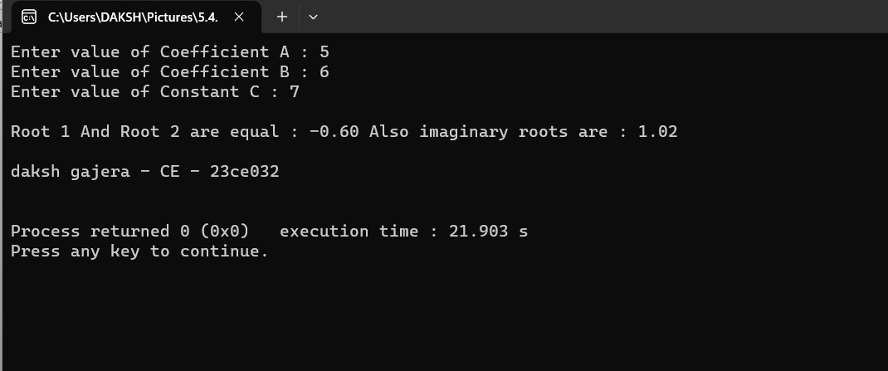

|  |  |
| --- | --- |
| **QUESTI ON** | 1. Have you learned about how to use normal switch case and nested switch case?   Ans: Yes,I learned about how to use switch and nested switch from this program.   1. Is default case necessary for every switch case? Ans: No. 2. What if break statement is not mentioned between two consecutive cases?   Ans: If we can’t use break statement then all case can be exicuted instead of only one case |

|  |  |
| --- | --- |
| **PROGRAM 5.5** | Write a program to input a character using getchar() and print the character using putchar() and check the character category. Also convert uppercase alphabet to lower case and vice versa.  (Use Character Test Functions : isalnum(), isalpha(), isdigit(), islower(), isprint(),  ispunct(), isspace(), isupper()) and (toupper() & tolower()) of h333eader file. |

|  |  |
| --- | --- |
| **ALGORYTH M** | **STEP 1:** Start  **STEP 2:** Declare variable ch  ch = getch() putchar(ch)  **STEP 3:** If(isalpha(ch))  If(islower(ch))  Print ch is lower case and convert it to upper case by using toupper.  else  Print ch is upper and convert it to lower casse by using tolower.  If(isdigit(ch)) Print ch is a digit  If(ispunct(ch))  Print ch is punctuation.  If(isalnum(ch))  Print ch is alpha numeric.  If(isspace(ch))  Print ch is a blank space  If(isprint(ch))  Print ch is not printable.  **STEP 4:** Stop |

# FLOWCHA RT

Start

Take input using getchar

If(isalpha)

If(islower)

Print ch is lower and convert in upper

Print ch is upper and convert in lower

If(isdigit) Print ch is

digit

If(ispunct) Print ch is

punctuation

If(isspace)

Print ch is blank space

If(isalnum)

Print ch is alpha numeric

If(isprint)

Print ch is not printable

Stop



|  |  |
| --- | --- |
| **CODE** |  |

|  |  |
| --- | --- |
| **OUTPUT** |  |

Sign: Grade: